TEMPORAL EFFECTIVENESS OF BIODIVERSITY SURROGATES IN CORAL REEFS IN THE BRITISH VIRGIN ISLANDS

BY

NICOLE B. KEEFNER

A THESIS SUBMITTED IN PARTIAL FULFILLMENT OF THE

REQUIREMENTS FOR THE DEGREE OF

MASTER OF SCIENCE

IN

BIOLOGICAL AND ENVIRONMENTAL SCIENCES

UNIVERSITY OF RHODE ISLAND

2019

MASTER OF SCIENCE THESIS

OF

NICOLE B. KEEFNER

APPROVED:

THESIS COMMITTEE:

MAJOR PROFESSOR: GRAHAM FORRESTER

CO-MAJOR PROFESSOR: BRIAN GERBER

GAVINO PUGGIONI

CARLOS PRADA

DEAN OF THE GRADUATE SCHOOL: NASSER ZAWIA

UNIVERSITY OF RHODE ISLAND

2019

# ABSTRACT

Taxonomic diversity on coral reefs has declined due to anthropogenic stressors. These declines have motivated monitoring programs to estimate species richness for major taxonomic groups: fish and corals. Due to logistical challenges of species identification, there have been efforts attempting to estimate species richness on reefs using landscape features as surrogates, simple indicators that provide an estimate of a target component of biodiversity, often referred to more simply as a target. Many of these efforts are limited in spatial or temporal scope, focus on rugosity and coral cover as predictors, and use coral and fish richnesses as proxies for total species richness. Here we examine how top surrogate-target relationships vary over 27 years and across 8 study sites. We also examine whether frequently measured landscape features of reefs can serve as reliable surrogates for sponge richness. Finally, this study is one of the first to investigate the ability of sponge cover to predict richness of dominant taxonomic groups on coral reefs. This study provides additional support to the idea that surrogate-target relationships should be assessed over space and time because it can provide insight into these relationships and how the ecosystem changes. We also show that including sponges in monitoring studies may provide a broader understanding of how biodiversity is changing on reefs.

# ACKNOWLEDGEMENTS

I would like to thank Dr. Graham Forrester, my major professor, for his continuous support and guidance throughout my time at the University of Rhode Island. I would also like to thank my co-major professor, Dr. Brian Gerber, and the committee members, Dr. Gavino Puggioni and Dr. Carlos Prada, for contributing so thoughtfully to the organization and analysis of this work. Thanks to Dr. Rachel Schwartz for chairing the committee and teaching me about version control for the programs I created for the analysis. For feedback and encouragement on presentations, early drafts, and discussions about my work, I am grateful to Elliot Lungu, Innocent Gumulira, Vida Osei, Erin Wampole, Dylan Ferreira, Juliana Masseloux, Sarah Holbrook, Katie Nickles, and Celeste Venolia. I extend my gratitude to my partner Anthony Peterson for trouble-shooting code with me. A special thanks to Dr. Lianna Jarecki and Linda Forrester who collected data used in this study. Thanks to Guana Island Staff for logistical support. This project would not have been possible without support from the University of Rhode Island through graduate teaching assistantships.

# DEDICATION

This thesis is dedicated to my loving mother, Teresa M. Keefner, my support in all things that led me to complete this work and the woman who taught me to persist through even the most inconceivable challenges.

# PREFACE

The following thesis has been submitted in manuscript format following the formatting guidelines of the *Journal for Nature Conservation*.

# TABLE OF CONTENTS

ABSTRACT ii

ACKNOWLEDGEMENTS iii

DEDICATION iv

PREFACE v

TABLE OF CONTENTS vi

LIST OF TABLES vii

LIST OF FIGURES viii

LIST OF APPENDICES ix

CHAPTER 1 1

Abstract 2

Introduction 3

Material and Methods 8

Results 14

Discussion 19

Acknowledgements 23

Literature Cited 24

Tables 33

Figures 37

Appendices 45

# LIST OF TABLES

Table 1. AICc table of models with coral richness as the response variable (target) and the candidate surrogates as predictors33

Table 2. AICc table of models with sponge richness as the response variable (target) and the candidate surrogates as predictors33

Table 3. AICc table of models with fish richness as the response variable (target) and the candidate surrogates as predictors33

Table 4. AICc table of models with combined richness as the response variable (target) and the candidate surrogates as predictors34

Table 5. AICc table of models with coral richness as the response variable (target) and percent coral cover as the top candidate surrogate34

Table 6. AICc table of models with sponge richness as the response variable (target) and percent coral cover as the top candidate surrogate35

Table 7. AICc table of models with fish richness as the response variable (target) and rugosity (in cm) as the top candidate surrogate35

Table 8. AICc table of models with combined richness as the response variable (target) and rugosity (in cm) as the top candidate surrogate36

# LIST OF FIGURES

Figure 1. Top panel: a map of Guana Island, British Virgin Islands showing the eight study sites: (1) Grand Ghut, (2) Pelican Ghut, (3) Bigelow Beach, (4) Monkey Point, (5) White Bay, (6) Iguana Head, (7) Crab Cove, and (8) Long Point, also known as Muskmelon. Lower panel: the location of Guana Island within the British Virgin Islands37

Figure 2. Plots of the targets (rows) and candidate surrogates (columns). 95% confidence intervals shown. Nagelkerke’s pseudo-r-squared values (*R*N2) are shown for the top candidate surrogate for each of the targets. Rugosity measured in centimeters.38

Figure 3. Temporal variation of coral richness as it varies with percent coral cover. Points represent observed values and lines represent predicted values.39

Figure 4. Spatial variation of sponge richness as it varies with percent coral cover across 8 monitoring sites. Points represent observed values and lines represent predicted values.40

Figure 5. Temporal variation of sponge richness as it varies with percent coral cover. Points represent observed values and lines represent predicted values.41

Figure 6. Spatial variation of fish richness as it varies with rugosity (in cm) across 8 monitoring sites. Points represent observed values and lines represent predicted values. Lines are truncated to correspond with the observed ranges of rugosity for each site.42

Figure 7. Spatial variation of combined richness as it varies with rugosity (in cm) across 8 monitoring sites, where combined richness is the sum of richnesses of corals, fishes, and sponges. Points represent observed values and lines represent predicted values. Lines are truncated to correspond with the observed ranges of rugosity for each site.43

Figure 8. Temporal variation of combined richness as it varies with rugosity (in cm), where combined richness is the sum of richnesses of corals, fishes, and sponges. Points represent observed values and lines represent predicted values.44

# LIST OF APPENDICES

Table A.1. Fish species included in richness calculations46

Table A.2. Benthic species included in richness calculations47

Figure A.3. Basic associations between the targets. Traditional r-squared values are shown.48

Figure A.4. Basic associations between the surrogates. Rugosity measured in centimeters. Traditional r-squared values are shown49

Figure A.5. Coral richness and coral cover over time. Basic goodness-of-fit lines shown50

# CHAPTER 1

Temporal effectiveness of biodiversity surrogates in coral reefs in the British Virgin Islands

**Authors**

Nicole B. Keefner[1]; Graham E. Forrester[2]

Manuscript in preparation for *Journal for Nature Conservation*

## Abstract

Taxonomic diversity on coral reefs has declined due to anthropogenic stressors. These declines have motivated monitoring programs to estimate species richness for major taxonomic groups: fish and corals. Due to logistical challenges of species identification, there have been efforts attempting to estimate species richness on reefs using landscape features as surrogates, simple indicators that provide an estimate of a target component of biodiversity, often referred to more simply as a target. Many of these efforts are limited in spatial or temporal scope, focus on rugosity and coral cover as predictors, and use coral and fish richnesses as proxies for total species richness. Here we examine how top surrogate-target relationships vary over 27 years and across 8 study sites. We also examine whether frequently measured landscape features of reefs can serve as reliable surrogates for sponge richness. Finally, this study is one of the first to investigate the ability of sponge cover to predict richness of dominant taxonomic groups on coral reefs. This study provides additional support to the idea that surrogate-target relationships should be assessed over space and time because it can provide insight into these relationships and how the ecosystem changes. We also show that including sponges in monitoring studies may provide a broader understanding of how biodiversity is changing on reefs.

*Keywords:* biodiversity surrogate, British Virgin Islands, Caribbean, coral diversity, fish diversity, sponge diversity.

## Introduction

Biodiversity declines associated with increasing levels of anthropogenic stress are of great concern because they reflect loss of species, disruption of community dynamics and diminished ecosystem function (Dobson et al., 2006; Duffy, 2009; Ehrlich & Wilson, 1991; Naeem, Thompson, Lawler, Lawton, & Woodfin, 1994; Staudinger et al., 2013; Stork, 2010). To monitor these declines, different aspects of biodiversity (landscape, ecosystem, taxonomic, and genetic) may be compared across similar systems over time and space (Duelli & Obrist, 2003; Noss, 1990). Taxonomic diversity, particularly species richness (a count of species in a defined area), is the most commonly studied component of biodiversity in ecological and conservation-related field research because it offers a simple, intuitive metric of biodiversity that can be readily compared across similar environments (Blake & Loiselle, 2000; Rahbek & Graves, 2001).

Coral reefs support high biodiversity and are globally threatened by environmental and anthropogenic stressors, including storms, ocean acidification, persistent high temperatures, coastal development, and overfishing (Comeau, Lantz, Edmunds, & Carpenter, 2016; Hughes, 1994; Hughes et al., 2017). Reef fishes and hard corals (Scleractinia) are important taxa in coral reef ecosystems because they help establish and maintain biodiversity and fill multiple functional roles (Bellwood, Hughes, Folke, & Nyström, 2004). They are also economically valuable because they attract tourists and fish serve as a valuable food source (Gill, Schuhmann, & Oxenford, 2015; Jennings & Polunin, 1996). Concerns regarding the declines of corals and fish, given their ecological and economic values, motivate many research programs to estimate the species richness of these groups in order to better understand causes of decline (Mouillot et al., 2014; Pratchett, Hoey, Wilson, Messmer, & Graham, 2011).

In an effort to more readily understand these declines, certain landscape features have been used to predict biodiversity on coral reefs. These landscape features can be thought of as potential surrogates, simple indicators that provide an estimate of a target component of biodiversity, often referred to more simply as a target (Noss, 1990). An effective surrogate has two essential features: first, it takes less time, money, and experience to measure than the target and second, it maintains a consistently strong correlation with the target over space and time (Colwell & Coddington, 1994; Magierowski & Johnson, 2006; Moreno, Rojas, Pineda, & Escobar, 2007).Evaluating the ability for landscape features to be used as surrogates might inform monitoring efforts that have limited resources and lead to a greater understanding of how the relationships between landscape features and biodiversity change over time and space. Most surrogate studies to date have been concerned with the effectiveness of surrogates across spatial scales (Anderson, Diebel, Blom, & Landers, 2005; Darling et al., 2017; Eglington, Noble, & Fuller, 2012; Smale, 2010). The prevalence of studies considering surrogates across spatial scales may be due to the widespread use of surrogates to identify priority conservation areas; this task requires an understanding of how the size and dispersion of the areas being conserved affects the relationship between the surrogate and target (Margules, Pressey, & Williams, 2002; Padoa-Schioppa, Baietto, Massa, & Bottoni, 2006; T. J. Ward, Vanderklift, Nicholls, & Kenchington, 1999). However, few studies have explicitly investigated surrogate effectiveness across temporal scales, and those that have are typically quite short (e.g., 13 months and 1 year; Magierowski & Johnson, 2006; Rubal, Veiga, Vieira, & Sousa-Pinto, 2011). Although not well-studied, several authors have argued that an effective surrogate must maintain a stable relationship with the target over time, in other words any environmental changes that influence the target must have a qualitatively similar influence on the surrogate (Bevilacqua, Mistri, Terlizzi, & Munari, 2018; Lewandowski, Noss, & Parsons, 2010; Mellin et al., 2011). The need for more studies that investigate the effectiveness of surrogates over time is evident.

Surrogates are used because a complete inventory of species present in an area is unattainable in many ecosystems, particularly in high diversity systems like coral reefs. Even for taxonomic groups that can be completely inventoried in principle, monitoring strategies that could detect all species in a given habitat are often prohibitively expensive and time-consuming (Kati et al., 2004). Monitoring species richness requires substantial taxonomic expertise (Derraik et al., 2002; Hirst, 2008; Sebek et al., 2012). Alternatively, landscape features that are good surrogates do not require species identification and can improve simplicity and affordability of studies. As a result, biologists have attempted to identify landscape features that may be used as simple predictors of reef biodiversity. The most commonly measured landscape features of coral reefs are percent hard coral cover (often, simply called coral cover) and structural complexity (rugosity). In fact, the temporal decline of these reef features is widely documented because they are so frequently measured (Alvarez-Filip, Dulvy, Gill, Côté, & Watkinson, 2009; Gardner, Côté, Gill, Grant, & Watkinson, 2003). Coral cover is expected to be a good surrogate for coral species richness because, presumably, the more area covered by corals, the greater variety of microhabitats they inhabit, and the greater number of species that would be present. Rugosity is expected to be a good surrogate for fish species richness because greater rugosity should provide a wider variety of structures that may be utilized by a greater diversity of fish species (Darling et al., 2017; Graham et al., 2006; Gratwicke & Speight, 2005; Newman et al., 2015). It has also been suggested that rugosity is a better surrogate for fish richness than percent coral cover because many fish species utilize the intact structure of the reef even when the coral is dead (Wilson, Graham, Pratchett, Jones, & Polunin, 2006).

Corals and fish are such conspicuous, well-studied taxonomic groups that the richnesses of these groups are often extrapolated to represent the richness of all taxonomic groups on coral reefs (Graham et al., 2006). The reliability of this extrapolation is not well-studied, and we used sponges as an additional target group in order to assess whether surrogates for fish and coral species richness can also be used to predict sponge richness. We selected sponges because they play a dominant role in the benthic composition of the reef and contribute to the reef’s three-dimensional structure (Bell, 2008), yet few studies have investigated sponge dynamics (Berman et al., 2013; Wulff, 2006). Here, we evaluate the ability of percent hard coral cover and rugosity to predict species richness of sponges to investigate whether these candidate surrogates can be used to predict other taxonomic groups on coral reefs. We also wanted to know how the percent cover of sponges (here, also called sponge cover) might serve as an alternative surrogate to percent hard coral cover and rugosity in predicting richness of corals, fish, sponges, and combined richness (as the sum of richness across these three groups).

Our main aim was to gain a better understanding of how surrogate-target relationships vary over time and space. In other words, we asked 1) can coral cover or rugosity predict sponge richness?, 2) how does sponge cover compare to coral cover and rugosity as a candidate surrogate for richness of corals, fish, sponges, and combined richness?, and 3) how do the top candidate surrogate-target relationships vary over space and time?. To address these questions, we used 27 years of monitoring data from eight sites around Guana Island in the British Virgin Islands (Forrester et al., 2015). Our first objective was to determine, for each of the four targets separately, which of these three candidate surrogates is the best predictor. Our second objective was to determine if the relationships between the top candidate surrogate for each target and the corresponding target remain consistent over space and time.

## Material and Methods

### Field study design

We used data collected as part of an ongoing monitoring program at eight sites around Guana Island in the British Virgin Islands (Forrester et al., 2015; Fig. 1). All sites were similar in covering 0.6-1.0 hectares of fringing coral reef adjacent to the island at a depth of 9-10 m. Sites varied in exposure to prevailing weather; sites on the windward north side of the island are more exposed than those on the southern leeward side (Fig. 1). Corals, fishes, and rugosity were sampled annually between June and August from 1992-2018, but sponges were not sampled in all years (no counts in 1992, 1996-1999, 2004, 1993 at Crab Cove, 2014 at Pelican Ghut, and 2017 at Bigelow Beach and Pelican Ghut). All surveys were performed using 30-m transects, placed at haphazardly selected locations within each site. The number of transects sampled per site varied among years (n = 3-22) but, for this study, three transects per site per year were selected at random for use in the analysis.

### Survey methods

Corals, sponges, fishes, and rugosity were sampled using well-established visual survey methods. Fishes were counted within a belt transect 30 m long x 1.5 m wide, and a T-shaped bar was used to determine the transect width as the diver swam along the transect line. Fish counts were restricted to species that are amenable to visual survey; that is, day-active species that are relatively site-attached and reliably visible to divers (Willis, 2001). Nocturnal species, highly mobile groups such as mackerels (Scombridae) and jacks (Carangidae) that are transient visitors to the sites, and small cryptic groups like gobies (Gobiidae) and blennies (Blennioidei) that often hide in crevices were not surveyed. Newly recruited juvenile fishes (< 1 month on the reef) were also excluded because their abundance is affected by lunar cycles, which complicates the detection of long-term trends (Robertson, 1992). Because fish were the only mobile organisms surveyed, the fish survey was conducted first for each transect in order to reduce the bias caused by divers disturbing the fish (Emslie, Cheal, MacNeil, Miller, & Sweatman, 2018).

Corals and other benthic taxa were surveyed using the linear point-intercept method, wherein a diver swam along the tape and identified the taxon under the tape at 0.25 m intervals (n = 120 points per transect; Canfield, 1941). Corals encountered were identified to species, where possible, but other taxa (including sponges) were classified into broader groupings. The point-intercept data was thus used to estimate coral species richness as well as the total abundance (% cover) of hard corals and sponges (Almada-Villela, Sale, Gold-Bouchot, & Kjerfve, 2003).

To estimate sponge species richness, sponges were surveyed using a line intercept method in which any sponge that intercepted the transect was recorded and identified to species, where possible.

Rugosity was measured as a proxy for three-dimensional structural complexity using the consecutive height difference method (McCormick, 1994), where a diver records the difference between the height of the transect tape and the substrate at 1 m intervals along the first 10 m of each transect. Rugosity (in cm) is calculated as the square root of the sum of the squared differences between successive height measurements, and so a value of 0 is flat and vertical complexity increases as the rugosity value increases.

To minimize bias introduced by using multiple observers, fish counts and sponge counts were each made by a single expert observer (Bernard, Götz, Kerwath, & Wilke, 2013; Thompson & Mapstone, 1997), though both observers compared their counts and species identifications to those of another expert one year (data not shown). Coral data were collected by three observers, but new observers’ species identifications and counts were calibrated with those of another observer during a training period of at least 15 dives before their data were incorporated into the study.

Because identifying taxa to species is not always possible or practical in field surveys, fish, corals, and sponges were identified to the most specific taxonomic group practical (Tables A.1-A.2). All fish were identified to species, while corals and sponges were sometimes identified as multi-species recognizable taxonomic units (D. F. Ward & Stanley, 2004), or RTU’s, for the following reasons: (1) taxonomists reassigned taxa thought to be different species to the same species after the study began, (2) taxonomists divided a single species into multiple species after the study began, and (3) several species are visually indistinguishable in the field. In all cases, the lowest resolution RTU was used, and for simplicity RTU’s are referred to as “species” hereafter. We suggest that the use of RTU’s, although it affects estimates of absolute species richness, should not alter the outcome of the analysis.

### Statistical Analysis

We used sites as replicates because they represent spatial units of relevance from both ecological and management perspectives. For surrogates (coral cover, sponge cover, and rugosity), replicates were thus means for the 3 randomly-selected transects per site per year. To estimate species richness, we pooled the 3 randomly-selected transects for each year and site and calculated the total number of species observed. Richness was calculated separately for each of the three focal taxonomic groups (fish, corals, and sponges), and combined species richness was thus only calculated for sites and years for which richness of all three taxonomic groups was available.

Based on first principles, we used negative binomial regression using the ‘MASS’ package to model richness because it is a count variable (Venables & Ripley, 2002). All models, therefore, have an additional parameter, theta, that accounts for overdispersion. There were no patterns in the Pearson residuals or deviance residuals for any of the models included in the analysis, indicating the data conformed to the assumptions of the negative binomial models used.

To determine which of the candidate surrogates is best at predicting each of the targets, we used simple models with only the candidate surrogates as predictors. We then compared these simple, surrogate-only models using Akaike Information Criterion corrected for small sample sizes (AICc; Mazerolle, 2019). AICc results provide a measure of parsimony in that they can be used to identify models with the fewest parameters and the greatest explanatory ability relative to other models in the model set. Top models were those with delta AICc ≤ 2 and AICc weights > 50%. Pseudo-r-squared values were also used for model interpretation by providing a measure of goodness-of-fit in that they can be used to compare how much each surrogate improves the ability to predict a given target. Pseudo-r-squared values were used in place of traditional r-squared values because the negative binomial distribution uses a log link function, for which there is no equivalent statistic to traditional r-squared as a measure of goodness-of-fit. Nagelkerke’s pseudo-r-squared (*R*N2) was used instead of other pseudo-r-squared metrics because it scales like traditional r-squared (ranges from 0-1) and is used to evaluate the improvement from a null to a fitted model. Only the top surrogate identified for each target from this comparison was used for subsequent modeling. We also examined simple correlations between the targets (between coral, fish, and sponge richnesses), as well as between the surrogates (between percent hard coral cover, rugosity, and percent sponge cover), to inform interpretations of the models.

To determine if relationships between top surrogates and the targets remain consistent over space and time, we added additional terms to the surrogate-only models to account for temporal variation and variation across sites. Site is a categorical predictor of the 8 locations around Guana Island and year models year-to-year trends over the duration of the study (27 years). For each of the targets (dependent variables), AICc was used to compare surrogate-only models to models with additional terms for year, site, and year plus site to test for variation in the data over time, across sites, or over time and across sites that cannot be accounted for by the surrogate alone. These additive models were also compared to models with interactive terms for the surrogate with year and the surrogate with site. These interactive models would suggest that the relationship between the target and the top candidate surrogate changes over time or across sites. We did not consider more complex models with higher-order interaction terms for this study because, if more complex models were supported, the relationship between the candidate surrogate and the target would not be valuable for monitoring purposes. In other words, the ecological interpretation of these more complex models would be complicated enough that there would be no clear relationship between the candidate surrogate and the target, suggesting that the candidate surrogates do not provide the benefits of a good surrogate. We used the same model selection procedure as above, where top models were those with delta AICc ≤ 2 and AICc weights > 50%. Nagelkerke’s pseudo-r-squared values (*R*N2) were also used for additional model support.

All data management and analysis was performed in the R programming language (R Core Team, 2019).

## Results

### Summary statistics

We recorded 205 species across all 27 years for all 8 sites around Guana Island. There were 117 fish species, 30 coral species, and 58 sponge species. For each site and year combination, coral richness ranged from 4 to 22 (mean = 13), sponge richness ranged from 8 to 36 (mean = 22), fish richness ranged from 9 to 37 (mean = 24), and combined richness ranged from 39 to 75 (mean = 59). Percent coral cover ranged from 2.68 to 61.75 (mean = 21.36), percent sponge cover ranged from 0.28 to 27.77 (mean = 7.96), and rugosity ranged from 17 to 78 cm (mean = 45.37 cm).

### Basic associations

Fish richness and coral richness were positively correlated, whereas sponge richness was negatively correlated to both of these, suggesting sponge richness varied in space and time independent of changes in fish and coral richness (Figure A.3). Similarly, rugosity and coral cover were positively correlated, whereas sponge cover was weakly and negatively correlated to both of these, suggesting sponge cover also varied in space and time independent of changes in rugosity and coral cover (Figure A.4).

### Objective 1: Identify top candidate surrogates

Coral cover and rugosity were both positively correlated with coral richness, but the correlation was stronger for coral cover and so it was the top candidate surrogate for coral richness (Table 1; Fig. 2). Sponge cover showed a weak positive association with sponge richness, and there was a weak negative association between coral cover and sponge richness. Coral cover, however, was a slightly better predictor of sponge richness than sponge cover and so, although none of the surrogates were highly correlated with the target, coral cover was the top candidate surrogate (Table 2; Fig. 2). Fish species richness was positively correlated with both coral cover and rugosity, but rugosity was the best predictor of fish richness and was the top candidate surrogate for fish richness (Table 3; Fig. 2) and combined richness (Table 4; Fig. 2).

### Objective 2: Top candidate surrogates over time and space

#### Coral Richness:

Variation in coral richness can partially be explained by coral cover as a candidate surrogate. However, the model with coral cover and year was the most competitive (*R*N2 = 0.69; Table 5), which means there were changes in coral richness over time that were not explained by the candidate surrogate alone. This suggests that there were temporal events that affected coral richness and coral cover differently. Evidence to support this can be seen by looking at each of these variables over time; average coral richness increased slightly over the study period, whereas coral cover steadily declined throughout the same period (Figure A.5). There was also support that the nature of the relationship between coral cover and coral richness (i.e. the slope of the relationship) changed over time (Table 5). In other words, the surrogate-target relationship was not stable over time because coral species richness increased over time for a given amount of coral cover. For example, a reef with 20 percent coral cover in 1992 was predicted to have about 9 coral species, whereas in 2018 it was predicted to have about 17 coral species (Fig. 3).

#### Sponge Richness:

Coral cover was the best predictor of sponge richness of the three candidate surrogates, but sponge richness was not well-predicted by any of our candidate surrogates (Fig. 2). There was thus considerable unexplained variation in sponge richness, some of which was associated with differences among sites and with change over time (*R*N2 = 0.71; Table 6). Unexplained spatial differences among the 8 sites had a greater influence on sponge richness than they did on coral cover (Fig. 4). For a given site, predicted sponge richness varied by about 2-3 species across the observed gradient of coral cover. Whereas, for a given amount of coral cover, predicted sponge richness differed by up to 8-9 species. With regards to temporal variation, sponge species richness slightly increased over the monitoring period for a given amount of coral cover. A site was likely to have about 3 more sponge species at the end of the monitoring period than at the beginning (Fig. 5). In summary, the surrogate-target relationship for sponge richness was weak and unstable in both space and time.

#### Fish Richness:

Fish richness can partially be explained by rugosity as a candidate surrogate. However, the top model had terms for both rugosity and site (*R*N2 = 0.82; Table 7), suggesting there were variations in fish richness across sites that were not explained by rugosity alone. These spatial variations among the 8 sites were likely due to the fact that, apart from White Bay (change in rugosity from 19-60 cm) and Crab Cove (change in rugosity from 26-57 cm), the other 6 sites remained quite distinct in rugosity over time. For example, Pelican Ghut had the lowest rugosity throughout the monitoring period, and correspondingly low fish richness (Fig. 6). Monkey Point had the next lowest rugosity and the next lowest fish richness, and so on. This may explain why the site-specific regression lines (Fig. 6) have shallower slopes than a line fit through all of the data (Fig. 2). In summary, the relationship between rugosity and fish richness was consistent over time, and, because rugosity varied more across sites than within a site, fish richness remained relatively stable over site and time and can be estimated by rugosity. Given this, sites with similar values for rugosity should have similar values of fish richness and this is evidence that rugosity can serve as an effective surrogate for fish richness.

#### Combined Richness:

Combined richness can partially be explained by rugosity as a candidate surrogate. However, the top model had terms for rugosity, year, and site (*R*N2 = 0.65; Table 8), suggesting there were variations in combined richness across sites and years that were not explained by rugosity alone. Similar to the relationship between rugosity and fish richness, these spatial variations among the 8 sites were likely due to distinct rugosity values for each site over time. The sites were organized differently on the y-axis for combined richness than they were for fish richness likely driven by variations in sponge richness across sites that follow a different pattern over time (Fig. 7). Similar to the association with fish richness above, the site-specific regression lines had shallower slopes than a line fit through all of the data due to the variation in rugosity over time at White Bay and Crab Cove (Fig. 2). With regards to temporal variation, combined species richness gradually increased over the monitoring period for a given amount of rugosity; a site was likely to have about 15 more species in 2018 than it had in 1993 (Fig. 8).

In summary, rugosity varied significantly across sites and not much within a site and combined richness increased gradually over time, suggesting combined richness can be predicted by rugosity at a given site and that this combined richness is expected to increase over time for a given level of rugosity. Rugosity may serve as a surrogate for combined richness across sites, but it failed to explain the increase in combined richness over time. There may be some other ecological explanation for this, such as the increase in sponge species over time having more of an impact on combined richness than the more subtle changes in fish and coral richness over the same time period.

## Discussion

### Assessing surrogate effectiveness over space and time

Local richness can vary for a variety of reasons, including: dispersal limitation, changes in environmental or landscape features, and competition over space.

Dispersal ability of reef species may be able to explain spatial variations in richness. It has been established that there is high variability in the distances traveled and dispersal mechanisms employed by different coral reef species (Jones et al., 2009). These differences in dispersal ability relate to genetic connectivity and, as a result, the biodiversity of reefs (Almany et al., 2009).

Changes in environmental or landscape features like those investigated in our study, such as rugosity and coral cover, may also be used to predict richness of taxonomic groups on coral reefs. Other studies have found that reduced coral richness resulted in a reduction of rugosity which, in turn, led to a decrease in fish abundance (Alvarez-Filip, Dulvy, Côté, Watkinson, & Gill, 2011). Although we did not include fish abundance as a target in our results, we did observe a reduction in the number of fish species and overall species present at lower levels of rugosity. We also found rugosity to be negatively associated with coral richness; however, we found coral cover to be a better surrogate of coral richness. The relationship between coral richness and coral cover varied over time; one explanation being, the increase in coral species richness for a given amount of coral cover over time is due to an increase in evenness over time. In other words, the abundance of the most dominant species is reduced over time. The study mentioned above found the variance in rugosity observed at higher levels of coral cover was the result of dominance by a particular genus of coral; some dominant corals were more structurally complex than other dominant corals (Alvarez-Filip et al., 2011). Spatial differences in rugosity governed patterns in fish richness and combined richness, and combined richness also increased over time. White Bay and Crab Cove had high variability in rugosity over time compared to other sites, suggesting there might be some factor affecting rugosity at these two sites leading to subsequent fluctuations in fish richness and combined richness.

Competition over space has been shown to be related to chemical inhibition, or allelopathy, in interspecific relationships between sponges and corals. These relationships may explain why coral cover was the top candidate surrogate for sponge richness and also why sponge cover and sponge richness are negatively correlated with coral cover and coral richness respectively. Allelopathic sponges, may reduce coral cover at local scales (Pawlik, Steindler, Henkel, Beer, & Ilan, 2007). Other studies have shown that unpalatable sponges, those that use chemicals to deter predation by fish, are also allelopathic toward corals and are relatively common on Caribbean coral reefs (Loh, McMurray, Henkel, Vicente, & Pawlik, 2015). Despite some potential benefits sponges can have on coral structures and reef nutrient cycles, even palatable sponges can outcompete corals for space by overgrowing coral structures (Loh & Pawlik, 2014; Stella, Pratchett, Hutchings, & Jones, 2011). Over time, the abundance of these palatable sponges has increased with the reduced abundance of spongivorous fish due to overfishing (Loh & Pawlik, 2014; Powell et al., 2014).

Species richness can vary across spatial and temporal scales for many reasons, some of which are described here. As such, studies proposing surrogates to predict species richness and other diversity measures should explicitly address the spatial and temporal limitations of using the candidate surrogates, especially when planning large-scale or long-term studies.

### Value of sponge monitoring

Different taxonomic groups respond differently to changes in the environment. As such, using diversity measures for one group as proxies for total biodiversity without evaluating this relationship (taxonomic surrogacy) can lead to false conclusions regarding taxonomic groups not directly measured. For example, windward reefs had higher coral and fish diversity than leeward reefs, but the latter supported higher sponge diversity (Acosta, Barnes, & McClatchey, 2015). Had this environmental gradient been extrapolated to diversity of taxonomic groups other than fish and corals, it may have been used to make management decisions that would negatively affect sponge diversity. Similarly, we found that sponges do not conform to the same patterns (over space, time, or with landscape features) as corals and fish. The traditional measures of coral cover and rugosity might be good predictors of coral richness and fish richness respectively, but caution should be exercised when making extrapolations to total reef diversity as richness of some groups, here we looked at sponge richness, is not strongly correlated with these variables. In addition, we found that sponge cover does not follow the same patterns as coral cover or rugosity over time or across sites. Perhaps sponges are not the only taxonomic group of organisms on coral reefs that are difficult to predict with coral cover or rugosity; there are many coral-associated invertebrates that may provide insight into coral reef diversity (Stella et al., 2011) and it is unlikely that all of these taxonomic groups will be adequately predicted by rugosity or coral cover alone.

Because sponge richness and sponge cover follow different patterns than other variables in this study, comparing patterns in sponges to other taxonomic groups and landscape features can provide a fuller picture of reef biodiversity. It has already been suggested that “non-umbrella” species can provide insight into overall site biodiversity at local scales in terrestrial ecosystems (Gerlach, Samways, & Pryke, 2013). As we show here, understudied taxonomic groups may not share surrogates with well-studied groups and the direction of the relationships may even be contradictory; something that has also been demonstrated in similar studies conducted in tropical forests (Lam et al., 2014). Therefore, diversity of these understudied taxonomic groups should be measured directly until a reliable surrogate can be identified. If not, studies that comment on species diversity should be transparent about which taxonomic groups they include in their estimates.

In conclusion, we show here that the commonly measured surrogates, rugosity and percent coral cover, can be reliable predictors of fish richness and coral richness respectively. However, we suggest that future reef biodiversity studies incorporate sponge-related measures to get a broader interpretation of reef biodiversity as they reveal different patterns than other measures. Reef biodiversity studies that do not incorporate sponge-related measures should be explicit about the taxonomic groups included in the analyses and exercise caution when estimating total reef biodiversity.

## Acknowledgements

Thanks to Dr. Brian Gerber, Dr. Gavino Puggioni, and Dr. Carlos Prada for their assistance in the development and review of this study. We are grateful to Dr. Lianna Jarecki and Linda Forrester who collected much of the data on sponges and corals. We also thank Dive BVI, UBS Divers, and the Guana Island staff for logistical support. Financial support came from the Falconwood Foundation and the National Science Foundation (OCE 0096061 and OCE 0222087).

## Literature Cited

Acosta, C., Barnes, R., & McClatchey, R. (2015). Spatial discordance in fish, coral, and sponge assemblages across a Caribbean atoll reef gradient. *Marine Ecology*, *36*, 167–177.

Almada-Villela, P. C., Sale, P. F., Gold-Bouchot, G., & Kjerfve, B. (2003). *Manual of methods for the MBRS synoptic monitoring program: Selected methods for monitoring physical and biological parameters for use in the Mesoamerican region*. Belize City: Mesoamerican Barrier Reef Systems project (MBRS).

Almany, G. R., Connolly, S. R., Heath, D. D., Hogan, J. D., Jones, G. P., McCook, L. J., … Williamson, D. H. (2009). Connectivity, biodiversity conservation and the design of marine reserve networks for coral reefs. *Coral Reefs*, *28*, 339–351.

Alvarez-Filip, L., Dulvy, N. K., Côté, I. M., Watkinson, A. R., & Gill, J. A. (2011). Coral identity underpins architectural complexity on Caribbean reefs. *Ecological Applications*, *21*(6), 2223–2231.

Alvarez-Filip, L., Dulvy, N. K., Gill, J. A., Côté, I. M., & Watkinson, A. R. (2009). Flattening of Caribbean coral reefs: Region-wide declines in architectural complexity. *Proceedings of the Royal Society B*, *276*, 3019–3025.

Anderson, M. J., Diebel, C. E., Blom, W. M., & Landers, T. J. (2005). Consistency and variation in kelp holdfast assemblages: Spatial patterns of biodiversity for the major phyla at different taxonomic resolutions. *Journal of Experimental Marine Biology and Ecology*, *320*, 35–56.

Bell, J. J. (2008). The functional roles of marine sponges. *Estuarine, Coastal and Shelf Science*, *79*, 341–353.

Bellwood, D. R., Hughes, T. P., Folke, C., & Nyström, M. (2004). Confronting the coral reef crisis. *Nature*, *429*, 827–833.

Berman, J., Burton, M., Gibbs, R., Lock, K., Newman, P., Jones, J., & Bell, J. (2013). Testing the suitability of a morphological monitoring approach for identifying temporal variability in a temperate sponge assemblage. *Journal for Nature Conservation*, *21*, 173–182.

Bernard, A. T. F., Götz, A., Kerwath, S. E., & Wilke, C. G. (2013). Observer bias and detection probability in underwater visual census of fish assemblages measured with independent double-observers. *Journal of Experimental Marine Biology and Ecology*, *443*, 75–84.

Bevilacqua, S., Mistri, M., Terlizzi, A., & Munari, C. (2018). Assessing the effectiveness of surrogates for species over time: Evidence from decadal monitoring of a Mediterranean transitional water ecosystem. *Marine Pollution Bulletin*, *131*, 507–514.

Blake, J. G., & Loiselle, B. A. (2000). Diversity of birds along an elevational gradient in the Cordillera Central, Costa Rica. *The Auk*, *117*(3), 663–686.

Canfield, R. H. (1941). Application of the line interception method in sampling range vegetation. *Journal of Forestry*, *39*, 388–394.

Colwell, R. K., & Coddington, J. A. (1994). Estimating terrestrial biodiversity through extrapolation. *Philosophical Transactions of the Royal Society B*, *345*, 101–118.

Comeau, S., Lantz, C. A., Edmunds, P. J., & Carpenter, R. C. (2016). Framework of barrier reefs threatened by ocean acidification. *Global Change Biology*, *22*, 1225–1234.

Darling, E. S., Graham, N. A. J., Januchowski-Hartley, F. A., Nash, K. L., Pratchett, M. S., & Wilson, S. K. (2017). Relationships between structural complexity, coral traits, and reef fish assemblages. *Coral Reefs*, *36*, 561–575.

Derraik, J. G. B., Closs, G. P., Dickinson, K. J. M., Sirvid, P., Barratt, B. I. P., & Patrick, B. H. (2002). Arthropod morphospecies versus taxonomic species: A case study with Araneae, Coleoptera, and Lepidoptera. *Conservation Biology*, *16*(4), 1015–1023.

Dobson, A., Lodge, D., Alder, J., Cumming, G. S., Keymer, J., McGlade, J., … Xenopoulos, M. A. (2006). Habitat loss, trophic collapse, and the decline of ecosystem services. *Ecology*, *87*(8), 1915–1924.

Duelli, P., & Obrist, M. K. (2003). Biodiversity indicators: The choice of values and measures. *Agriculture, Ecosystems and Environment*, *98*, 87–98.

Duffy, J. E. (2009). Why biodiversity is important to the functioning of real-world ecosystems. *Frontiers in Ecology and the Environment*, *7*(8), 437–444.

Eglington, S. M., Noble, D. G., & Fuller, R. J. (2012). A meta-analysis of spatial relationships in species richness across taxa: Birds as indicators of wider biodiversity in temperate regions. *Journal for Nature Conservation*, *20*, 301–309.

Ehrlich, P. R., & Wilson, E. O. (1991). Biodiversity studies: Science and policy. *Science*, *253*(5021), 758–762.

Emslie, M. J., Cheal, A. J., MacNeil, M. A., Miller, I. R., & Sweatman, H. P. A. (2018). Reef fish communities are spooked by scuba surveys and may take hours to recover. *PeerJ*.

Forrester, G., Baily, P., Conetta, D., Forrester, L., Kintzing, E., & Jarecki, L. (2015). Comparing monitoring data collected by volunteers and professionals shows that citizen scientists can detect long-term change on coral reefs. *Journal for Nature Conservation*, *24*, 1–9.

Gardner, T. A., Côté, I. M., Gill, J. A., Grant, A., & Watkinson, A. R. (2003). Long-term region-wide declines in Caribbean corals. *Science*, *301*, 958–960.

Gerlach, J., Samways, M., & Pryke, J. (2013). Terrestrial invertebrates as bioindicators: An overview of available taxonomic groups. *Journal of Insect Conservation*, *17*(4), 831–850.

Gill, D. A., Schuhmann, P. W., & Oxenford, H. A. (2015). Recreational diver preferences for reef fish attributes: Economic implications of future change. *Ecological Economics*, *111*, 48–57.

Graham, N. A. J., Wilson, S. K., Jennings, S., Polunin, N. V. C., Bijoux, J. P., & Robinson, J. (2006). Dynamic fragility of oceanic coral reef ecosystems. *Proceedings of the National Academy of Sciences of the United States of America*, *103*(22), 8425–8429.

Gratwicke, B., & Speight, M. R. (2005). The relationship between fish species richness, abundance and habitat complexity in a range of shallow tropical marine habitats. *Journal of Fish Biology*, *66*, 650–667.

Hirst, A. J. (2008). Surrogate measures for assessing cryptic faunal biodiversity on macroalgal-dominated subtidal reefs. *Biological Conservation*, *141*, 211–220.

Hughes, T. P. (1994). Catastrophes, phase shifts, and large-scale degradation of a Caribbean coral reef. *Science*, *265*(5178), 1547–1551.

Hughes, T. P., Kerry, J. T., Álvarez-Noriega, M., Álvarez-Romero, J. G., Anderson, K. D., Baird, A. H., … Wilson, S. K. (2017). Global warming and recurrent mass bleaching of corals. *Nature*, *543*, 373–377.

Jennings, S., & Polunin, N. V. C. (1996). Impacts of fishing on tropical reef ecosystems. *Ambio*, *25*(1), 44–49.

Jones, G. P., Almany, G. R., Russ, G. R., Sale, P. F., Steneck, R. S., Van Oppen, M. J. H., & Willis, B. L. (2009). Larval retention and connectivity among populations of corals and reef fishes: History, advances and challenges. *Coral Reefs*, *28*, 307–325.

Kati, V., Devillers, P., Dufrêne, M., Legakis, A., Vokou, D., & Lebrun, P. (2004). Testing the value of six taxonomic groups as biodiversity indicators at a local scale. *Conservation Biology*, *18*(3), 667–675.

Lam, T. Y., Fletcher, C., Ramage, B. S., Doll, H. M., Joann, C. L., Nur-Zati, A. M., … Potts, M. D. (2014). Using Habitat Characteristics to Predict Faunal Diversity in Tropical Production Forests. *Biotropica*, *46*(1), 50–57.

Lewandowski, A. S., Noss, R. F., & Parsons, D. R. (2010). The effectiveness of surrogate taxa for the representation of biodiversity. *Conservation Biology*, *24*(5), 1367–1377.

Loh, T.-L., McMurray, S. E., Henkel, T. P., Vicente, J., & Pawlik, J. R. (2015). Indirect effects of overfishing on Caribbean reefs: Sponges overgrow reef-building corals. *PeerJ*.

Loh, T.-L., & Pawlik, J. R. (2014). Chemical defenses and resource trade-offs structure sponge communities on Caribbean coral reefs. *Proceedings of the National Academy of Sciences of the United States of America*, *111*(11), 4151–4156.

Magierowski, R. H., & Johnson, C. R. (2006). Robustness of surrogates of biodiversity in marine benthic communities. *Ecological Applications*, *16*(6), 2264–2275.

Margules, C. R., Pressey, R. L., & Williams, P. H. (2002). Representing biodiversity: Data and procedures for identifying priority areas for conservation. *Journal of Biosciences*, *27*(4), 309–326.

Mazerolle, M. J. (2019). AICcmodavg: Model selection and multimodel inference based on (Q)AIC(c).

McCormick, M. I. (1994). Comparison of field methods for measuring surface topography and their associations with a tropical reef fish assemblage. *Marine Ecology Progress Series*, *112*, 87–96.

Mellin, C., Delean, S., Caley, J., Edgar, G., Meekan, M., Pitcher, R., … Bradshaw, C. (2011). Effectiveness of biological surrogates for predicting patterns of marine biodiversity: A global meta-analysis. *PLoS ONE*, *6*(6).

Moreno, C. E., Rojas, G. S., Pineda, E., & Escobar, F. (2007). Shortcuts for biodiversity evaluation: A review of terminology and recommendations for the use of target groups, bioindicators and surrogates. *International Journal of Environment and Health*, *1*(1), 71–86.

Mouillot, D., Villéger, S., Parravicini, V., Kulbicki, M., Arias-González, J. E., Bender, M., … Bellwood, D. R. (2014). Functional over-redundancy and high functional vulnerability in global fish faunas on tropical reefs. *Proceedings of the National Academy of Sciences of the United States of America*, *111*(38), 13757–13762.

Naeem, S., Thompson, L. J., Lawler, S. P., Lawton, J. H., & Woodfin, R. M. (1994). Declining biodiversity can alter the performance of ecosystems. *Nature*, *368*(6473), 734–737.

Newman, S. P., Meesters, E. H., Dryden, C. S., Williams, S. M., Sanchez, C., Mumby, P. J., & Polunin, N. V. C. (2015). Reef flattening effects on total richness and species responses in the Caribbean. *Journal of Animal Ecology*, *84*, 1678–1689.

Noss, R. F. (1990). Indicators for monitoring biodiversity: A hierarchical approach. *Conservation Biology*, *4*(4), 355–364.

Padoa-Schioppa, E., Baietto, M., Massa, R., & Bottoni, L. (2006). Bird communities as bioindicators: The focal species concept in agricultural landscapes. *Ecological Indicators*, *6*, 83–93.

Pawlik, J. R., Steindler, L., Henkel, T. P., Beer, S., & Ilan, M. (2007). Chemical warfare on coral reefs: Sponge metabolites differentially affect coral symbiosis in situ. *Limnology and Oceanography*, *52*(2), 907–911.

Powell, A., Smith, D. J., Hepburn, L. J., Jones, T., Berman, J., Jompa, J., & Bell, J. J. (2014). Reduced Diversity and High Sponge Abundance on a Sedimented Indo-Pacific Reef System: Implications for Future Changes in Environmental Quality. *Plos One*.

Pratchett, M. S., Hoey, A. S., Wilson, S. K., Messmer, V., & Graham, N. A. J. (2011). Changes in biodiversity and functioning of reef fish assemblages following coral bleaching and coral loss. *Diversity*, *3*, 424–452.

R Core Team. (2019). R: A language and environment for statistical computing. Vienna, Austria: R Foundation for Statistical Computing.

Rahbek, C., & Graves, G. R. (2001). Multiscale assessment of patterns of avian species richness. *Proceedings of the National Academy of Sciences of the United States of America*, *98*(8), 4534–4539.

Robertson, D. R. (1992). Patterns of lunar settlement and early recruitment in Caribbean reef fishes at Panamá. *Marine Biology*, *114*, 527–537.

Rubal, M., Veiga, P., Vieira, R., & Sousa-Pinto, I. (2011). Seasonal patterns of tidepool macroalgal assemblages in the North of Portugal. Consistence between species and functional group approaches. *Journal of Sea Research*, *66*, 187–194.

Sebek, P., Barnouin, T., Brin, A., Brustel, H., Dufrêne, M., Gosselin, F., … Bouget, C. (2012). A test for assessment of saproxylic beetle biodiversity using subsets of “monitoring species.” *Ecological Indicators*, *20*, 304–315.

Smale, D. A. (2010). Monitoring marine macroalgae: The influence of spatial scale on the usefulness of biodiversity surrogates. *Diversity and Distributions*, *16*, 985–995.

Staudinger, M. D., Carter, S. L., Cross, M. S., Dubois, N. S., Duffy, J. E., Enquist, C., … Turner, W. (2013). Biodiversity in a changing climate: A synthesis of current and projected trends in the US. *Frontiers in Ecology and the Environment*, *11*(9), 465–473.

Stella, J. S., Pratchett, M. S., Hutchings, P. A., & Jones, G. P. (2011). Coral-associated invertebrates: Diversity, ecological importance and vulnerability to disturbance. *Oceanography and Marine Biology: An Annual Review*, *49*, 43–104.

Stork, N. E. (2010). Re-assessing current extinction rates. *Biodiversity and Conservation*, *19*, 357–371.

Thompson, A. A., & Mapstone, B. D. (1997). Observer effects and training in underwater visual surveys of reef fishes. *Marine Ecology Progress Series*, *154*, 53–63.

Venables, W. N., & Ripley, B. D. (2002). *Modern applied statistics with S* (Fourth). New York, New York: Springer.

Ward, D. F., & Stanley, M. C. (2004). The value of RTUs and parataxonomy versus taxonomic species. *New Zealand Entomologist*, *27*, 3–9.

Ward, T. J., Vanderklift, M. A., Nicholls, A. O., & Kenchington, R. A. (1999). Selecting marine reserves using habitats and species assemblages as surrogates for biological diversity. *Ecological Applications*, *9*(2), 691–698.

Willis, T. J. (2001). Visual census methods underestimate density and diversity of cryptic reef fishes. *Journal of Fish Biology*, *59*, 1408–1411.

Wilson, S. K., Graham, N. A. J., Pratchett, M. S., Jones, G. P., & Polunin, N. V. C. (2006). Multiple disturbances and the global degradation of coral reefs: Are reef fishes at risk or resilient? *Global Change Biology*, *12*, 2220–2234.

Wulff, J. L. (2006). Rapid diversity and abundance decline in a Caribbean coral reef sponge community. *Biological Conservation*, *127*, 167–176.

## Tables

Table 1. AICc table of models with coral richness as the response variable (target) and the candidate surrogates as predictors.*K is the number of parameters in the model.

|  |  |  |  |  |  |
| --- | --- | --- | --- | --- | --- |
| **Model Name** | **K\*** | **AICc** | **Delta AICc** | **Akaike weight** | **Log-likelihood** |
| coral cover | 3 | 1058.2 | 0.0 | 1.00 | -526.1 |
| rugosity | 3 | 1131.2 | 73.0 | 0.00 | -562.5 |
| sponge cover | 3 | 1161.1 | 102.8 | 0.00 | -577.5 |

Table 2. AICc table of models with sponge richness as the response variable (target) and the candidate surrogates as predictors.*K is the number of parameters in the model.

|  |  |  |  |  |  |
| --- | --- | --- | --- | --- | --- |
| **Model Name** | **K\*** | **AICc** | **Delta AICc** | **Akaike weight** | **Log-likelihood** |
| coral cover | 3 | 967.5 | 0.0 | 0.96 | -480.7 |
| sponge cover | 3 | 973.9 | 6.4 | 0.04 | -483.9 |
| rugosity | 3 | 995.4 | 27.9 | 0.00 | -494.6 |

Table 3. AICc table of models with fish richness as the response variable (target) and the candidate surrogates as predictors.*K is the number of parameters in the model.

|  |  |  |  |  |  |
| --- | --- | --- | --- | --- | --- |
| **Model Name** | **K\*** | **AICc** | **Delta AICc** | **Akaike weight** | **Log-likelihood** |
| rugosity | 3 | 1266.3 | 0.0 | 1.00 | -630.1 |
| coral cover | 3 | 1295.4 | 29.2 | 0.00 | -644.7 |
| sponge cover | 3 | 1359.7 | 93.4 | 0.00 | -676.8 |

Table 4. AICc table of models with combined richness as the response variable (target) and the candidate surrogates as predictors.*K is the number of parameters in the model.

|  |  |  |  |  |  |
| --- | --- | --- | --- | --- | --- |
| **Model Name** | **K\*** | **AICc** | **Delta AICc** | **Akaike weight** | **Log-likelihood** |
| rugosity | 3 | 1106.8 | 0.0 | 0.99 | -550.3 |
| coral cover | 3 | 1116.3 | 9.6 | 0.01 | -555.1 |
| sponge cover | 3 | 1153.8 | 47.1 | 0.00 | -573.8 |

Table 5. AICc table of models with coral richness as the response variable (target) and percent coral cover as the top candidate surrogate. *K is the number of parameters in the model.

|  |  |  |  |  |  |
| --- | --- | --- | --- | --- | --- |
| **Model Name** | **K\*** | **AICc** | **Delta AICc** | **Akaike weight** | **Log-likelihood** |
| coral cover + year | 4 | 1044.2 | 0.0 | 0.58 | -518.0 |
| coral cover + year + year*coral cover | 5 | 1045.6 | 1.4 | 0.29 | -517.7 |
| coral cover + year + site | 11 | 1047.2 | 2.9 | 0.13 | -511.9 |
| coral cover | 3 | 1058.2 | 14.0 | 0.00 | -526.1 |
| coral cover + site | 10 | 1062.5 | 18.3 | 0.00 | -520.7 |
| coral cover + site + site*coral cover | 17 | 1064.2 | 19.9 | 0.00 | -513.5 |

Table 6. AICc table of models with sponge richness as the response variable (target) and percent coral cover as the top candidate surrogate. *K is the number of parameters in the model.

|  |  |  |  |  |  |
| --- | --- | --- | --- | --- | --- |
| **Model Name** | **K\*** | **AICc** | **Delta AICc** | **Akaike weight** | **Log-likelihood** |
| coral cover + year + site | 11 | 909.3 | 0.0 | 1.00 | -442.8 |
| coral cover + site | 10 | 922.3 | 12.9 | 0.00 | -450.4 |
| coral cover + site + site*coral cover | 17 | 933.8 | 24.5 | 0.00 | -447.8 |
| coral cover + year | 4 | 966.3 | 56.9 | 0.00 | -479.0 |
| coral cover + year + year*coral cover | 5 | 966.6 | 57.3 | 0.00 | -478.1 |
| coral cover | 3 | 967.5 | 58.2 | 0.00 | -480.7 |

Table 7. AICc table of models with fish richness as the response variable (target) and rugosity (in cm) as the top candidate surrogate. *K is the number of parameters in the model.

|  |  |  |  |  |  |
| --- | --- | --- | --- | --- | --- |
| **Model Name** | **K\*** | **AICc** | **Delta AICc** | **Akaike weight** | **Log-likelihood** |
| rugosity + site | 10 | 1203.8 | 0.0 | 0.75 | -591.4 |
| rugosity + year + site | 11 | 1206.0 | 2.2 | 0.25 | -591.4 |
| rugosity + site + site*rugosity | 17 | 1217.0 | 13.2 | 0.00 | -590.0 |
| rugosity + year + year*rugosity | 5 | 1260.9 | 57.1 | 0.00 | -625.3 |
| rugosity + year | 4 | 1261.6 | 57.8 | 0.00 | -626.7 |
| rugosity | 3 | 1266.3 | 62.4 | 0.00 | -630.1 |

Table 8. AICc table of models with combined richness as the response variable (target) and rugosity (in cm) as the top candidate surrogate. *K is the number of parameters in the model.

|  |  |  |  |  |  |
| --- | --- | --- | --- | --- | --- |
| **Model Name** | **K\*** | **AICc** | **Delta AICc** | **Akaike weight** | **Log-likelihood** |
| rugosity + year + site | 11 | 1079.7 | 0.0 | 0.96 | -528.0 |
| rugosity + site | 10 | 1086.5 | 6.8 | 0.03 | -532.5 |
| rugosity + year | 4 | 1092.8 | 13.1 | 0.00 | -542.3 |
| rugosity + site + site*rugosity | 17 | 1093.2 | 13.5 | 0.00 | -527.5 |
| rugosity + year + year*rugosity | 5 | 1094.8 | 15.1 | 0.00 | -542.2 |
| rugosity | 3 | 1106.8 | 27.0 | 0.00 | -550.3 |

## Figures



Figure 1. Top panel: a map of Guana Island, British Virgin Islands showing the eight study sites: (1) Grand Ghut, (2) Pelican Ghut, (3) Bigelow Beach, (4) Monkey Point, (5) White Bay, (6) Iguana Head, (7) Crab Cove, and (8) Long Point, also known as Muskmelon. Lower panel: the location of Guana Island within the British Virgin Islands.

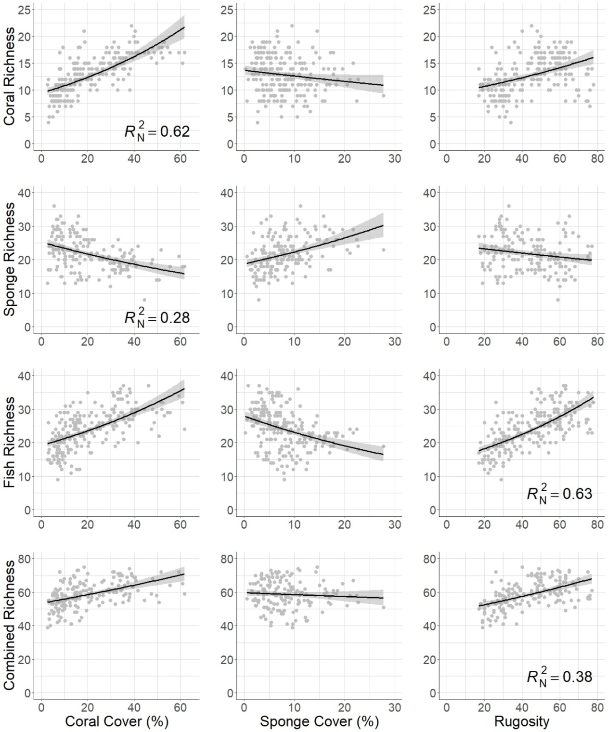

Figure 2. Plots of the targets (rows) and candidate surrogates (columns). 95% confidence intervals shown. Nagelkerke’s pseudo-r-squared values (*R*N2) are shown for the top candidate surrogate for each of the targets. Rugosity measured in centimeters.

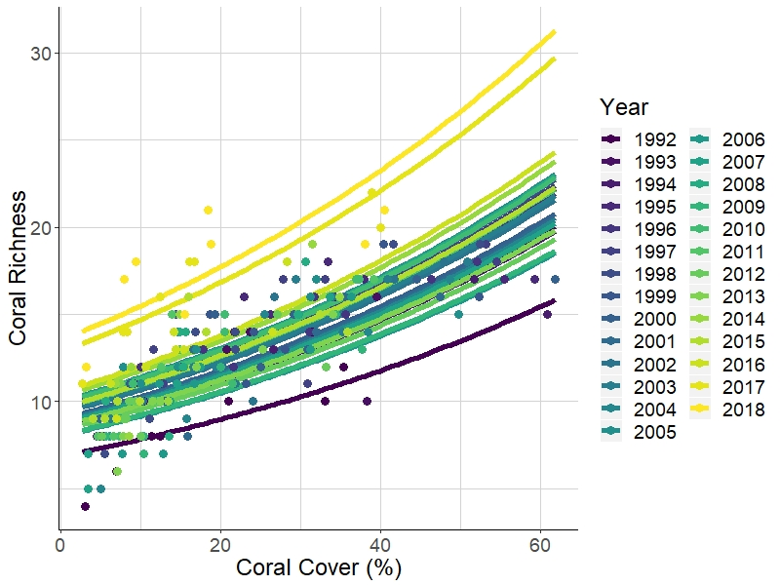

Figure 3. Temporal variation of coral richness as it varies with percent coral cover. Points represent observed values and lines represent predicted values.

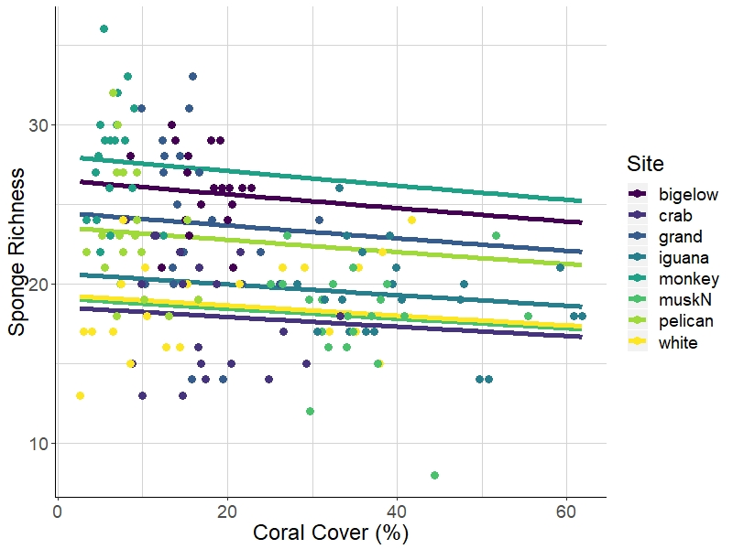

Figure 4. Spatial variation of sponge richness as it varies with percent coral cover across 8 monitoring sites. Points represent observed values and lines represent predicted values.

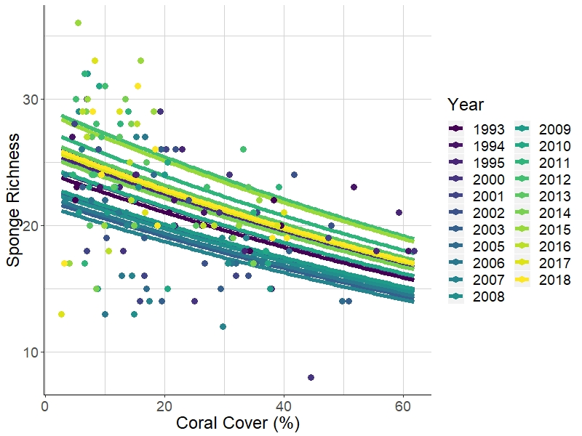

Figure 5. Temporal variation of sponge richness as it varies with percent coral cover. Points represent observed values and lines represent predicted values.

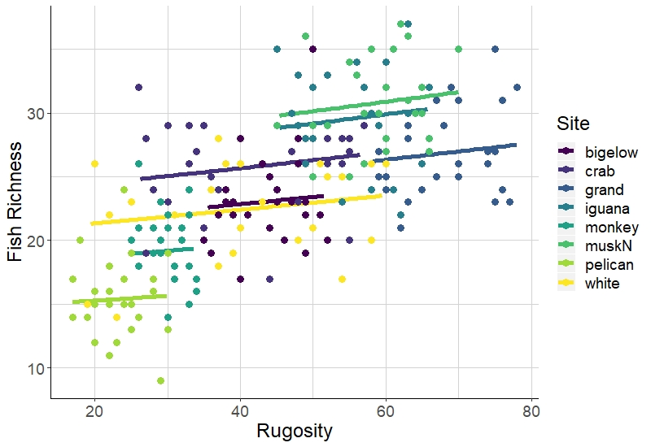

Figure 6. Spatial variation of fish richness as it varies with rugosity (in cm) across 8 monitoring sites. Points represent observed values and lines represent predicted values. Lines are truncated to correspond with the observed ranges of rugosity for each site.

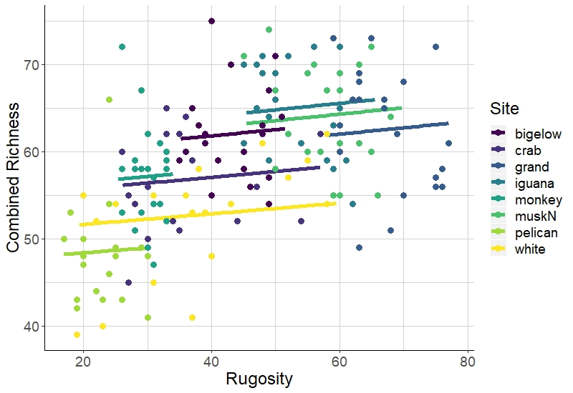

Figure 7. Spatial variation of combined richness as it varies with rugosity (in cm) across 8 monitoring sites, where combined richness is the sum of richnesses of corals, fishes, and sponges. Points represent observed values and lines represent predicted values. Lines are truncated to correspond with the observed ranges of rugosity for each site.

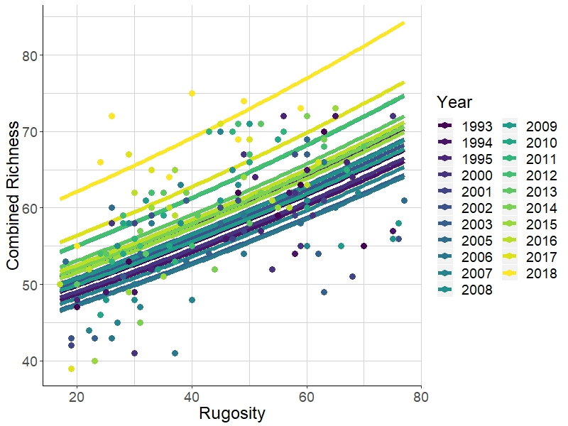

Figure 8. Temporal variation of combined richness as it varies with rugosity (in cm), where combined richness is the sum of richnesses of corals, fishes, and sponges. Points represent observed values and lines represent predicted values.

## Appendices

Table A.1. Fish species included in richness calculations.

|  |  |  |  |
| --- | --- | --- | --- |
| Fish species | Fish common name | Fish species cont. | Fish common name cont. |
| Abudefduf saxatilis | Sergeant major | Hypoplectrus chlorurus | yellowtail hamlet |
| Acanthurus bahianus | ocean surgeon | Hypoplectrus guttavarius | shy hamlet |
| Acanthurus chirurgus | doctorfish | Hypoplectrus indigo | indigo hamlet |
| Acanthurus coeruleus | blue tang | Hypoplectrus nigricans | black hamlet |
| Aluterus scriptus | scrawled filefish | Hypoplectrus puella | barred hamlet |
| Amblycirrhitus pinos | redspotted hawkfish | Hypoplectrus sp. | tan hamlet |
| Anisotremus surinamensis | black margate | Hypoplectrus unicolor | butter hamlet |
| Anisotremus virginicus | porkfish | Inermia vittata | boga |
| Aulostomus maculatus | trumpetfish | Kyphosus sectatrix | gray chub |
| Balistes capriscus | gray triggerfish | Lachnolaimus maximus | hogfish |
| Balistes vetula | queen triggerfish | Lactophrys bicaudalis | spotted trunkfish |
| Bodianus rufus | Spanish hogfish | Lactophrys quadricornis | scrawled cowfish |
| Calamus calamus | saucereye porgy | Lactophrys triqueter | smooth trunkfish |
| Calamus pennatula | pluma porgy | Lutjanus apodus | schoolmaster snapper |
| Cantherhines macrocerus | whitespotted filefish | Lutjanus griseus | gray snapper |
| Cantherhines pullus | orangespotted filefish | Lutjanus jocu | dog snapper |
| Canthigaster rostrata | sharp-nose puffer fish | Lutjanus mahogoni | mahogany snapper |
| Centropyge argi | cherubfish | Lutjanus synagris | lane snapper |
| Chaetodipterus faber | Atlantic spadefish | Melichthys niger | black durgon |
| Chaetodon ocellatus | spotfin butterflyfish | Microspathodon chrysurus | yellowtail damselfish |
| Chaetodon sedentarius | reef butterflyfish | Monacanthus ciliatus | fringed filefish |
| Chaetodon striatus | banded butterflyfish | Monacanthus tuckeri | slender filefish |
| Chaetodon capistratus | foureye butterflyfish | Mulloidichthys martinicus | yellow goatfish |
| Chromis cyanea | blue chromis | Mycteroperca tigris | tiger grouper |
| Chromis insolata | sunshinefish | Mycteroperca venenosa | yellowfin grouper |
| Chromis multilineata | brown chromis | Nicholsina usta | emerald parrotfish |
| Clepticus parrae | creole wrasse | Ocyurus chrysurus | yellowtail snapper |
| Cryptotomus roseus | bluelip parrotfish | Odontoscion dentex | reef croaker |
| Diodon hystrix | porcupinefish | Pomacanthus arcuatus | gray angelfish |
| Epinephelus adscensionis | rock hind | Pomacanthus paru | French angelfish |
| Epinephelus guttatus | red hind | Pomacentrus diencaeus | longfin damselfish |
| Epinephelus cruentatus | graysby | Pomacentrus leucostictus | beaugregory |
| Epinephelus fulva | coney | Pomacentrus variabilis | cocoa damselfish |
| Epinephelus striatus | Nassau grouper | Pomacentrus fuscus | dusky damselfish |
| Equetus acuminatus | high-hat | Pomacentrus partitus | bicolor damselfish |
| Equetus lanceolatus | jacknife fish | Pomacentrus planifrons | threespot damselfish |
| Equetus punctatus | spotted drum | Pseudupeneus maculatus | spotted goatfish |
| Gerres cinereus | yellowfin mojarra | Pterois volitans | lionfish |
| Gramma loreto | fairy basslet | Scarus coeruleus | blue parrotfish |
| Haemulon aurolineatum | tomtate grunt | Scarus croicensis | striped parrotfish |
| Haemulon carbonarium | Caesar grunt | Scarus guacamaia | rainbow parrotfish |
| Haemulon chrysargyreum | smallmouth grunt | Scarus taeniopterus | princess parrotfish |
| Haemulon flavolineatum | French grunt | Scarus vetula | queen parrotfish |
| Haemulon macrostomum | Spanish grunt | Serranus baldwini | lantern bass |
| Haemulon melanurum | cottonwick grunt | Serranus tabacarius | tobacco fish |
| Haemulon plumierii | white grunt | Serranus tigrinus | harlequin bass |
| Haemulon sciurus | blue striped grunt | Serranus tortugarum | chalk bass |
| Haemulon sp. unidentified | unidentified grunt | Sparisoma atomarium | greenblotch parrotfish |
| Haemulon striatum | striped grunt | Sparisoma aurofrenatum | redband parrotfish |
| Halichoeres bivittatus | slippery dick | Sparisoma chrysopterum | redtail parrotfish |
| Halichoeres cyanocephalus | yellowcheek wrasse | Sparisoma radians | bucktooth parrotfish |
| Halichoeres garnoti | yellowhead wrasse | Sparisoma rubripinne | yellowtail parrotfish |
| Halichoeres maculipinna | clown wrasse | Sparisoma viride | stoplight parrotfish |
| Halichoeres pictus | rainbow wrasse | Sphoeroides dorsalis | marbled puffer |
| Halichoeres poeyi | blackear wrasse | Sphoeroides spengleri | bandtail puffer |
| Halichoeres radiatus | puddingwife | Synodus intermedius | sand diver |
| Holacanthus ciliaris | queen angelfish | Synodus saurus | bluestripe lizardfish |
| Holacanthus tricolor | rock beauty | Synodus synodus | red lizardfish |
|  |  | Thalassoma bifasciatum | bluehead wrasse |

Table A.2. Benthic species included in richness calculations.

|  |  |
| --- | --- |
| **Coral species** | **Sponge species** |
| Acropora cervicornis | Agelas citrina, Agelas clathrodes, or Clathria faviformis |
| Acropora palmata | Agelas conifera |
| Agaricia agaricites | Agelas spp. |
| Agaricia spp. (mostly Agaricia humilis | Aiolochroia crassa and Verongula rigida |
| and Agaricia lamarcki) | Amphimedon compressa |
| Cladocora arbuscula | Amphimedon sp. (maybe Amphimedon complanata) |
| Colpophyllia natans | Amphimedon viridis |
| Dendrogyra cylindrus | Aplysina fistularis, Aplysina fulva, and Aplysina insularis |
| Diploria labyrinthiformis | Aplysina cauliformis |
| Diploria strigosa and Diploria clivosa | Aplysina lacunosa, Suberea sp., and Verongula reiswigi |
| Dichocoenia stokesi | Artemisina melana or Iotrochota arenosa |
| Eusmilia fastigiata | Black, spiny, purple exudate, but not slimy |
| Favia fragum | Breadcrumb (Calyx podatypa, Svenzea |
| Helioceris cucullata | cristinae, or Svenzea zeai) |
| Isophyllia sinuosa | Callyspongia fallax |
| Manicina areolata | Like Callyspongia fallax but soft with pinched tube ends |
| Montastraea cavernosa | Callyspongia plicifera |
| Madracis mirabilis and Madracis decactis | Callyspongia vaginalis |
| Meandrina meandrites | Cervicornia cuspidifera |
| Montastraea annularis, M. franksi, M. faveolata | Chondrilla caribensis |
| (genus name now Orbicella) | Cinachyrella kuekenthali |
| Mussa angulosa | Clathria venosa |
| Mycetophyllia ferox, Mycetophyllia lamarckiana | Clathria virgultosa |
| Oculina spp. | Cliona delitrix |
| Porites astreoides | Cliona laticavicola |
| Porites colonensis | Cliona varians |
| Porites furcata | Cribochalina vasculum and Petrosia pellasarca |
| Porites porites | Desmapsamma anchorata |
| Scolymia spp. | Dictyonella funicularis |
| Siderastrea siderea and Siderastrea radians | Dragmacidon reticulatum |
| Solenastrea bournoni | Dysidea janiae |
| Stephanocoenia intersepta | Dysidea sp. (maybe etheria) |
|  | Ectyoplasia ferox |
|  | Halisarca caerulea |
|  | Higginsia coralloides (may include Ptilocaulis walpersii) |
|  | Hyrtios sp. or Spheciospongia vesparium |
|  | Iotrochota birotulata |
|  | Iotrochota sp. |
|  | Ircinia campana |
|  | Ircinia felix |
|  | Ircinia strobilina |
|  | Maybe "Ircinia smooth" or Spongia |
|  | Monanchora arbuscula |
|  | Mycale laevis |
|  | Mycale laxissima |
|  | Neofibularia nolitangere |
|  | Neopetrosia proxima (may include |
|  | Xestospongia subtriangularis) |
|  | Niphates erecta (may include Niphates amorpha) |
|  | Niphates sp. or Lissodendoryx sp.? |
|  | Orange encrusting |
|  | Pandaros acanthifolium |
|  | Plakortis sp. |
|  | Red Encrusting |
|  | Scopalina ruetzleri |
|  | Spirastrella coccinea and Spirastrella hartmani |
|  | Spongosorites coralliphaga |
|  | Tectitethya crypta |
|  | Unidentified |
|  | Xestospongia muta |

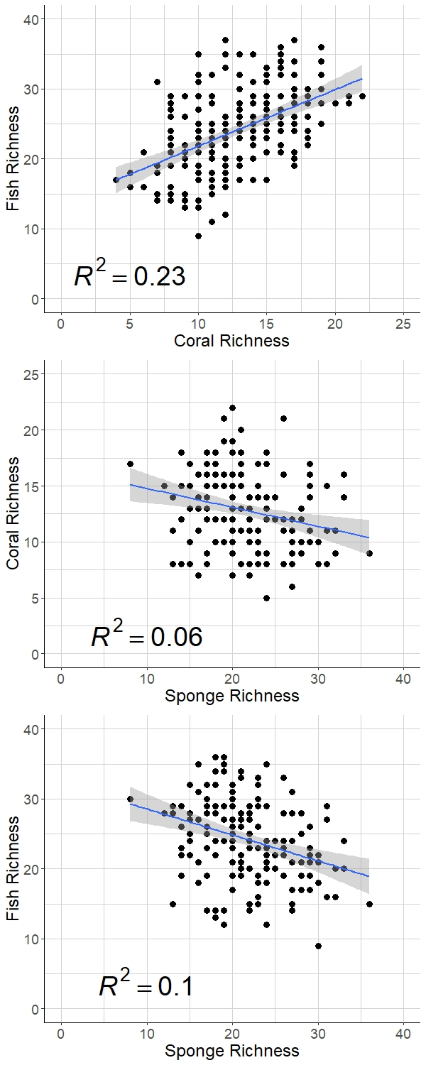

Figure A.3. Basic associations between the targets. Traditional r-squared values are shown.

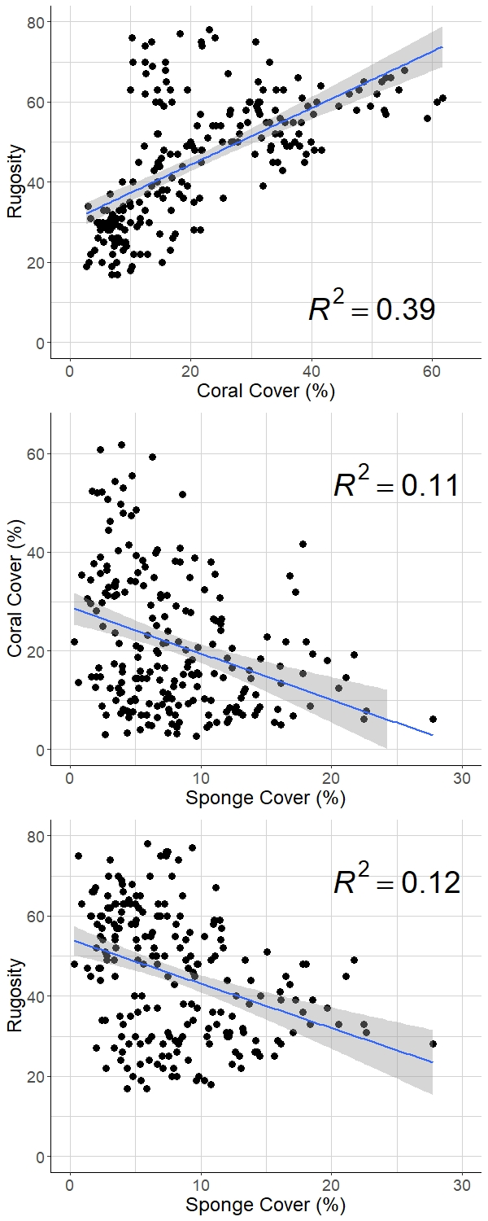

Figure A.4. Basic associations between the surrogates. Rugosity measured in centimeters. Traditional r-squared values are shown.

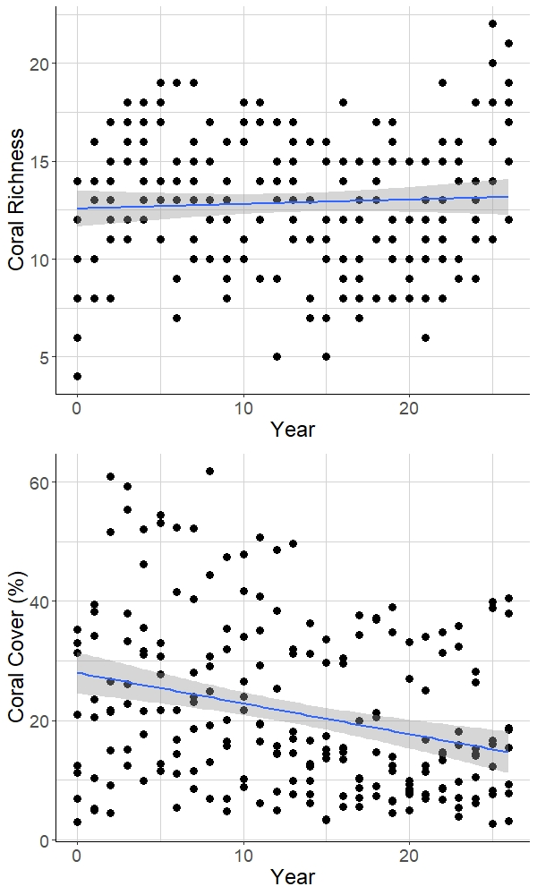

Figure A.5. Coral richness and coral cover over time. Basic goodness-of-fit lines shown.

1. Department of Natural Resources Science, University of Rhode Island, Kingston, RI 02881, USA ; nicole-keefner@uri.edu
2. Department of Natural Resources Science, University of Rhode Island, Kingston, RI 02881, USA; gforrester@uri.edu